**THE KNOLLS NEWS**

**Winston Knolls Civic Association**

P.O. Box 2893

Springfield, Virginia 22152

**Sharing News of Common Interest March 2018**

**Annual WKCA Membership Drive - Your Form Enclosed**

***Membership Drive 5 March – 8 April, Dues only $20 per year!***

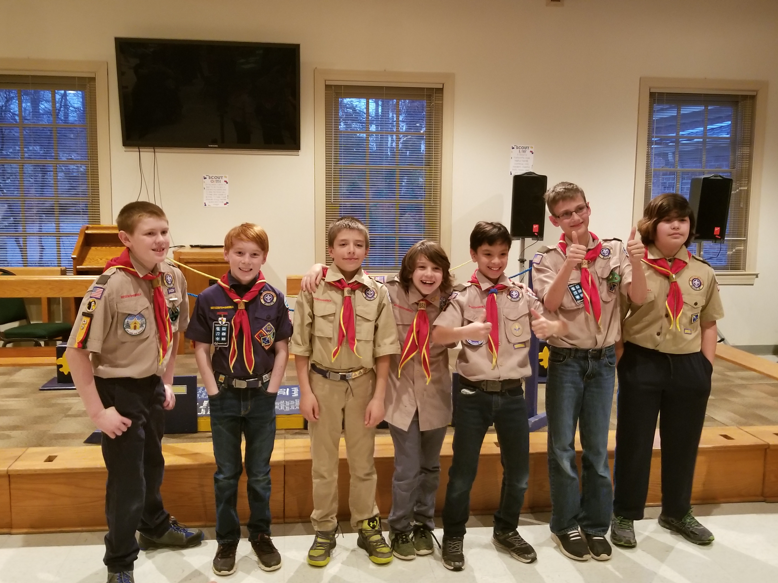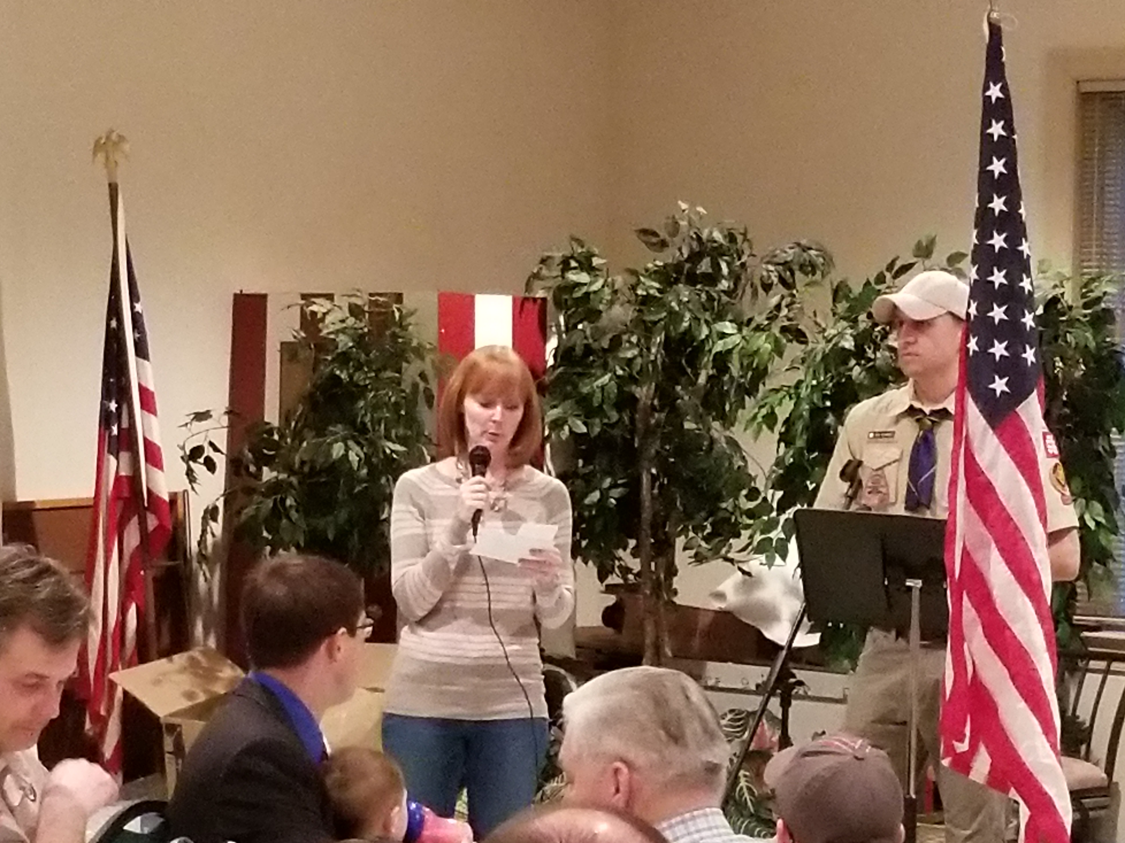Open this newsletter and pull out the WKCA Membership form along with a return envelope to send in your form and dues; we need you to renew your membership! The WKCA can only continue to provide the services, events and activities we all enjoy through the continued membership of our Winston Knolls residents – both owners and those renting a home in the community. **Even if you decide not to join the WKCA, please update the form and send it in, so your listing and our data base is up to date.** Be a good neighbor and please support our Association, a small price with a big return!

**Winston Knolls**

Winston Knolls Civic Association membership is voluntary and offered to each of our 489 homes. We sponsor civic-minded events and promote and protect the wellbeing of our neighborhood!

**Website Resource for WKCA**

**www.wknolls.net**

The Knolls News is a periodic publication of the Winston Knolls Civic Association, and is distributed free to all 489 homes in the community. Classified advertisements are free to members of the Civic Association. Business advertisements are also available for a fee. We encourage you to use our advertisers, and expect that you will do your own research before employing persons to work on your home or property. For information on any article or on WK advertising rates, please contact Tom Blume at kathandtomblume@gmail.com.

**Advertising Rates:**

**Business card size: $20.00**

**One-fourth page: $35.00**

**One-third page: $45.00**

**One-half page: $60.00**

**One-Full page: $100.00**

**Keli Jacewitz was the WKCA representative at Pack 685’s Annual Blue/Gold Dinner Feb 24, 2018**

**See Below What Your Dues Pay For**

**Knolls News – Printed at least quarterly, providing information on WKCA activities, home improvement tips, committee reports, neighborhood news, and more!**

**Neighborhood Directory – An excellent resource is published biennially. 2019 is the next printing. Keeping our data base current is a must.**

**Social Events – Sponsoring events like the 4th of July Parade/Ice Cream Social, Halloween Parade and Party, Community Picnic, and more.**

**Service - Twice a year Large Pick up and shredding, plus extra dumpster in the spring for yard trash**

**WKCA sponsors Cub Scout Pack 685**

**Advocacy – Gathering information on issues of importance to WK residents, sharing it, gathering input, and representing the community as appropriate**

**Beautification – Sponsoring Cleanup Day in the spring, planting scrubs/flowers, fund ~$2,200.00 dollars annually for the mowing of Huntsman median sidewalks, and sign area throughout the spring/summer to keep up property values in the community.**

**Neighborhood Watch – Working with local authorities and looking out for each other.**

**Are you new to the neighborhood?**

**If you recently have become a Winston Knolls resident or know of a new family that has moved into the neighborhood over the holidays or in the last few months, please contact Sue Ehlers, our Welcome Wagon Chairman at** [**sue.ehlers@verizon.netor**](mailto:sue.ehlers@verizon.netor) **or Kathy Sherman, our Directory/Database Chairman at** [**kjsherman3@gmail.com or**](mailto:kjsherman3@gmail.com%20or) **in order for us to get their information into our database.**

**Message from Winston Knolls President - February 2017**

Dear Neighbors and Friends – 2017 was a busy, but good year for our Association and I hope you had a chance to enjoy one or more of our sponsored activities/events. Now that the holidays are over we our lives are back to semi-normal, I want to thank you for your contributions in making our community a great place to live and to the many volunteers who plan and support our activities. The Civic Association is establishing our new website that will be user friendly and enable individuals to update their data electronically, plus other new features. Please bear with us as we update the site, “wknolls.net”. Although, the site is not completely populated it is the current site for WKCA. I ask that you review the new site and let us know what you think. We have also revived the neighborhood watch, headed up by Keli Jacewitz, so stand by for her to contact you for support. The December annual meeting was well attended and Mr. Herrity, our District Supervisor took questions from the audience after his opening comments. Besides the normal business of the association, the 2018 Budget was passed along with the election of Officers. Your WKCA 2018 Officers are: President – Tom Blume, Vice President – Jeff Lins, Treasurer – Ed Linz, and Secretary – Jennifer Williams. Below is a list of our Committee Chairs who we could not do without and also a list of our up and coming activities. The WKCA board is in need of volunteers to fill positions of long serving officers and committee chairs who would like to turn over their role to someone new or who have pasted their 5 year service limit according to our bylaws. The Civic Association attended the annual Cub Scout Dinner and it was quite an event. For those that do not know Pack 685 and Pack 686 have merged into one Pack and we are the Charter member for the Pack. We are very proud to be associated with such a worthwhile organization. Please contact me to learn more about the board and the role you could fill as a volunteer for the community. No prior experience is necessary – Call me at 703-569-2368. In closing, our Membership Drive has started and I hope you’ll be renewing your membership or starting a new membership, in order to help support the many important services, events and activities provided by the WKCA. We are counting on a strong membership drive to be able to continue to offer these benefits to the community. We need at least 380 of the 489 homes in the WKCA area residents to join, in order to conduct business and keep our reserve at a manageable level. I ask that you please fill out the enclosed insert and mail it back to the Civic Association in order to continue to provide activities for the community. Again thanks to all who support the Civic Association; without you we would not exist!

***WKCA COMMITTEE Chairs:***

* **Membership - Kathy Sherman**
* **Social - Stacey Ivie/Kate Thorne**
* **Education - Ed Linz**
* **Biennial Directory and Member Data Base - Kathy Sherman**
* **Web Site Chairman - Micah MacDonald**
* **Home Improvement - VACANT**
* **Neighborhood Watch - Keli Jacewitz**
* **Newsletter -Tom Blume**
* **Grounds Maintenance – Fred Blum**
* **Welcome Wagon - Sue Ehlers**
* **Sign Area Beautification - Terri & Alan Perry**

**“The WKCA 2018 “Meetings & Activities”**

* **Board meeting –21 Feb at 7PM, Tom Blume’s house, 8908 Arley Drive**
* **Cub Scout Annual Pack 685 Blue and Gold Dinner 24 Feb**
* **Newsletter Distributed 3 / 4 March**
* **Board meeting –21 Mar at 7PM, Tom Blume’s house, 8908 Arley Drive**
* **Block Captains start their canvasing for memberships in the month of April**
* **WKCA Cleanup (Cub Scouts)/Dumpster Day at Spur Road – 14 April (WKCA & HOA Residents only)**
* **Board meeting –18 April at 7PM, Tom Blume’s house, 8908 Arley Drive**
* **Deadline for articles to WKCA Newsletter – April 21**
* **Newsletter Distributed 28 / 29 April**
* **WKCA & OHECA Community yard sale Saturday – 5 May**
* **WKCA & OHECA Community Large pick up and shredding Saturday, 12 May at OHES, Furniture, mattresses, monitors, TVs, grills, lawnmowers and etc., no paint or hazardous material**
* **Board meeting – 23 May at 7PM, Tom Blume’s house, 8908 Arley Drive**
* **No board meetings in June and July**
* **Annual Members Picnic tentatively scheduled for 9 June at Hanks Place**
* **4th of July Parade and Ice Cream Social. Parade Starts at Hunt Valley School at 1245**
* **Nationals Night Out, first Tuesday in August (Security/Neighborhood Watch Event)**

Page 2

**Education Chair Report**

**by Ed Linz**

The renovation of West Springfield High School continues to progress well and appears to be on schedule for completion in the fall of 2019. The Science, Math, and English departments are now in classrooms in the newly completed section which also houses the main entrance, admin offices and library. This entrance is now located on the south side of the building facing what used to be the student parking lot. Parking and vehicle access to the school remains a significant issue, according to Principal Mike Mukai. It will continue to be a challenge for the foreseeable future as work continues. Renovation of the main gym will now begin with a target of completing the work prior to the fall sports season. Updated information about the renovation can be found at the following link:

**www2.fcps.edu/westspringfieldhs/about_wshs/renovation.html**

Students now have Social Studies and Foreign Languages classes in trailers, but when the renovation is complete, the capacity of the school will have been increased to 2400, eliminating the use of trailers. The current enrollment is 2263, projected to be approximately 2300 in the fall. Mr. Mukai said that these numbers are considerably higher than previous county projections because a large number of private school students are returning to public education – at least here in the Springfield area.

On a school related issue, the WKCA Board continues to encourage our residents whose property faces Huntsman Boulevard to inspect your yards for trees and vegetation which protrude into the walking areas along Huntsman which our children use to walk to Orange Hunt Elementary School. Please trim these bushes and trees to provide a safe walkway.

Speaking of trees (on a totally unrelated issue!) we recently had one of the original silver maple trees on our lot taken down because it had become dangerously high. The company which did the work, Tommy Cubbage Tree Service, 540-718-7978, was both reasonably priced and very professional.

Page 3

**Stay informed w/the Consumer Affairs Branch**

Ensure that you review the NEW [Consumer Affairs Branch](http://www.fairfaxcounty.gov/consumer/) e-Newsletter, The Informed Consume. The Informed Consumer is a quarterly publication designed to keep Fairfax County residents updated on consumer issues. The current issue of The Informed Consumer is available online and you can also go to, <http://www.fairfaxcounty.gov/consumer>.

**Springfield District 2018 Paving and Restriping Meeting**

**4/05/2018 7:00 pm**

The Virginia Department of Transportation and Fairfax County Department of Transportation will host a community information meeting to discuss this year’s [paving and restriping efforts in the Springfield District](https://www.fairfaxcounty.gov/transportation/2018-paving-and-restriping/springfield-district-paving-and-restriping) on Thursday, April 5, 7:00 to 8:30 p.m., in the Springfield Governmental Center, 6140 Rolling Road, West Springfield. The meeting provides residents with an opportunity to speak directly with road engineers and transportation planners about the paving program, proposed striping changes and general traffic safety concerns. Information about paving and restriping in the Springfield District will be on display in an open house format, with a presentation at 7:15 p.m. Community members are invited to give feedback on general traffic safety concerns regarding roads scheduled for paving, and the proposed striping changes at the meeting or by submitting comments online via the [comment form](https://www.fairfaxcounty.gov/transportation/springfield-district-paving-and-restriping-feedback) on the [paving and restriping program page](https://www.fairfaxcounty.gov/transportation/2018-paving-and-restriping/springfield-district-paving-and-restriping). Comments will be accepted through April 15, 2018.

**Medical Fraud**

Medical Identity Theft and Medicare fraud is on the rise and is costing the government and consumers millions of dollars. Not every billing mistake is fraud, however, a true billing mistake is usually a simple fix. Although fraud is not an easy fix there are ways to protect yourself or a loved one from becoming a victim. Protect Your Personal Information by (1) Keeping your Medicare number as private as your social security number; (2) Be wary of offers for free medical equipment or services; (3) If it’s really free you don’t need to give them your Medicare number; (4) Medicare and Medicaid personnel don’t

do home visits; and (5) Loaning your Medicare number to anyone is illegal.

**CLASSIFIED ADS**

*All non-business ads (For Sale, Garage Sales, Wanted, Babysitters, etc.) are free to WKCA residents as long as membership fees are up to date. Please submit your request to kjsherman3@gmail.com*

**NEIGHBORHOOD WATCH:**

We need your support for our Neighborhood Watch program to assist in the maintaining the safety of our neighborhood. Anyone who is 18 years or older may join.

**Please contact our WKCA coordinator: Keli Jacewitz** [kjacewitz@gmail.com](mailto:kjacewitz@gmail.com) **or 703-912-7610**

**ITEMS FOR SALE:**

Fisher-Price Little People, Kid K'nex, Lego Duplo, and other name-brand children and toddler toys for sale. All gently used, but clean and in good condition. All priced between $5 and $15 for each set or kit. Inquiries to Ann at [annbsun@aol.com](mailto:annbsun@aol.com) or 703.451.5647 for details.

Wedding Dress Size 4, veil and Petticoat.  Price negotiable.  Call Oksana Hoobchaak at [(703) 569-1059](tel:(703)%20569-1059)

**LAWNCARE/MOWING:**

TJ Brantley (teen) call: 703-451-0077

Joe Burns (teen) call: 703-455-1820

Andrew Burns (teen) call: 703-455-1820

Ian Elkins (teen) call: 937-903-9441

**BABYSITTING:**

Sydney Schaffer (teen) call: 703 303-6824

Grace O’Grady (teen) call: 703-913-3464

Amanda Richardson (teen) call: 703-644-0508

Rebecca Richardson (teen) call: 703-644-0508

Audrey Valentine (teen) call: 703-625-7299

Amy Peterson (teen) call: 703-912-6363

Reed Gray (teen) call: 757-705-8835

TJ Brantley (teen) call: 703-451-0077

Marie Cluff (teen) call: 610-704-6087

**PET WALKERS/SITTERS:**

Sydney Schaffer (teen) call: 703 303-6824

Joey MacDonald (teen) call: 571-533-0003

Amy Peterson (teen) call: 703-912-6363

Reed Gray (teen) call: 757-705-8835

Lauren Cluff (teen) call: 610-505-0440

Erin Burns (teen) call: 703-455-1820

Joseph Harris (teen) 202-255-3068

Sam Harris (teen) 202-255-3068

**SEAMSTRESS/SEWING:**

Carol Cluff (Adult) call: 610-505-0440

|  |
| --- |
| **Fun Part Time Job for Moms**  **WALKING THE DOGS, LLC**  **Local dog walking and pet sitting company is currently seeking fit adults for permanent year round positions. Ready to become part of a fun dynamic team? We have been successfully taking care of local pets since 2007. The perfect job for stay at home moms, or retirees! Cell phone, internet, reliable vehicle, and flexibility are a necessity. Competitive pay and fun work environment!  Call Abbie at (703)473-9768**  MCj03317140000[1]  **Walking The Dogs, LLC**  [www.walkingdogsva.com](http://www.walkingdogsva.com)  **703-473-9768** |

**Page 5**